TERM-2 CCNA Assignment

**Module 7 Network fundamentals**

# Advance Question

## Explain Network Topologies

* + 1. The way the data is transferred and the devices are connected how the network topology will take shape.bus, star, ring, mesh, tree.

## Explain TCP/IP Networking Model

* + 1. TCP/IP stands for Transmission Control Protocol/Internet Protocol and is a suite of communication used to interconnect the network device in Internet.

## Explain LAN and WAN Network

* + 1. **LAN is a computer network established within a small geographic area, such as a house, office or buildings. WAN, on the other side, is a computer network that covers a broad geographical area**.

## Explain Operation of Switch

* + 1. Switches are primarily binary devices: either fully on or off and light switches have a simple design. When the switch is turned off, the circuit breaks and the power flow is interrupted. Circuits consist of a source of power and load.

## Describe the purpose and functions of various network devices

* + 1. It can transmit and receive wireless HART data and perform the basic function necessary to support network formation and maintenance.

## Make list of the appropriate media, cables, ports, and connectors to connect switches to other

* + 1. Access port, Ethernet crossover cable.

## Define Network devices and hosts

* + 1. **The devices which are used for communication between different hardware's used in the computer network are know as Network devices.**

## What are Ethernet Standard (802.3) and Frame Formats?

* + 1. **In case of classic Ethernet it is an 8 byte field and in case of IEEE 802.3 it is of 7 bytes**.

# Intermediate Question

## Comparison between UTP, MM and SM Ethernet Cabling

* 1. **single mode fiber is designed to propagate a single light mode whereas multimode supports multiple simultaneous light modes**.

## Make Cross cable

* 1. For crossover cables, simply make one end of the cable a T568A and the other end a T568B. Now you can make Ethernet cables of any length, fix broken connectors, or make yourself a crossover cable.

## Make Straight-Through Cable

* 1. These cables are the most common. They are best when connecting two different types of networking equipment. For instance, they are appropriate for connecting a computer to a switch, router or printer.

## Explain ARP, ICMP and Domain name

* 1. **ARP is a layer 2 (As it finds the IP address using MAC address {broadcast} ) ICMP is a layer 3 (Used to reach and check the path using IP address)** ICMP messages communicate information about network connectivity issues back to the source of the compromised transmission. This is what

users type in a browser's search bar to directly access your website.

## Describe the components required for network and Internet communications

* 1. A network has 5 basic components viz clients, server, channel, Inetrface devices.

## Explain Encapsulation and DE capsulation in OSI Reference model

* 1. **Encapsulation adds information to a packet as it travels to its destination. Decapsulation reverses the process by removing the info, so a destination device can read the original data**.

## Explain network segmentation and basic traffic management concepts

* 1. **Network segment Is a networking architectural design that divides a network into multiple segments (subnets) with each functioning as a smaller, individual network**.

## What is flow control and acknowledgment**?**

* 1. Flow Control is an essential function of the data link layer. It determines the amount of data that a sender can send. It makes the sender wait until an acknowledgment is received from the receiver's end. Methods of Flow Control are Stop-and-wait , and Sliding window.

# Advance question

## Use the OSI and TCP/IP models and their associated protocols to explain how data Flows in a network

* + - 1. Both the reference models are based upon layered architecture. The layers in the models are compared with each other. The physical layer and the data link layer of the OSI model correspond to the link layer of the TCP/IP model. The network layers and the transport layers are the same in both the models.

## Identify and explain at layers 1, 2, 3, and 7 using a layered model approach

* + - 1. In the OSI reference model, the communications between a computing system are split into seven

different abstraction layers: physical, Data link.

## Explain CSMA/CD and CSMA/CA

* + - 1. CSMA/CA stands for Carrier Sense Multiple Access / Collision Avoidance is a network protocol for carrier transmission. Like CSMA/CD it is also operated in the medium access control layer.

## Explain this frame and find layer

* + - 1. In the OSI model of computer networking, a frame is a the protocol data unit at the data link

layer, Frames are the result of the final layer of encapsulation before the data is transmitted over the physical layer.

## Draw and explain Cisco hierarchical model

A. DONE

## Drawing of a typical wired and wireless enterprise LAN

A. DONE

## Describe the uses of straight-through and crossover Ethernet cables

A. A straight-through cable is a type of twisted pair cable that is used in local area networks to connect a computer to a network hub such as a router.

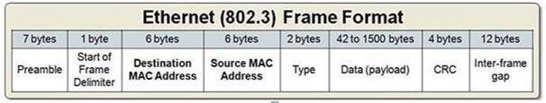

## Explain Layer 2 and Layer 3 Switch

* + - 1. Layer 2 switches are often used to reduce data traffic on a LAN. Because they use MAC addresses only, an unidentified device attempting to use the network will be denied. On the other hand, Layer 3 switches are primarily used to operate VLANs and improve security.

## Identifying Collision and Broadcast Domains

* + - 1. **The Collision domain is a network section that allows traffic to flow forward and backward. A Broadcast domain is a type of Domain wherein traffic flows all over the network**.

.



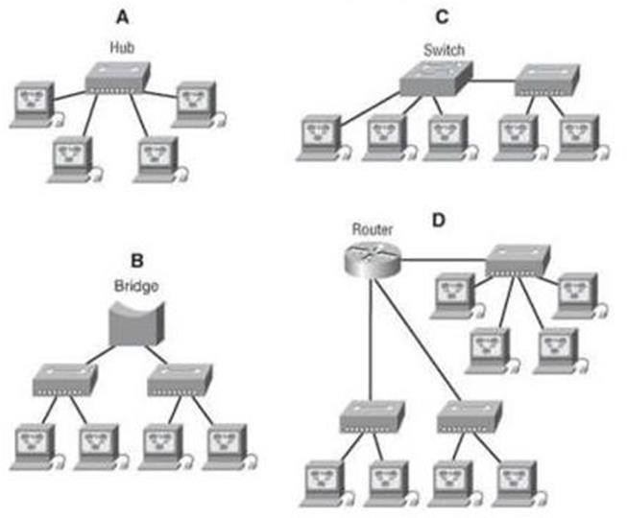

## Explain Spanning Tree Protocol

* + - 1. STP was created to avoid the problems that arise when computers exchange data on a local area network (LAN) that contains redundant paths.

## Explain uncast Multicast and Broadcast

* + - 1. A Unicast communication is from one device on the network to another device on the network. A MultiCast communication is from one device on the network to many, but not all, devices on the network. A Broadcast communication is from one device on the network to all devices on the network.

## Explain CAM (Content Addressable Memory)

* + - 1. Content-addressable memory (CAM) is **computer memory that operates like a hardware search engine for search-intensive applications**. CAM is capable of searching its entire contents in a single clock cycle.

## Explain CAM (Ternary Content Addressable Memory)

* + - 1. CAM Is **a specialized type of high-speed memory that searches its entire contents in a single clock cycle**.

## Which command use of Show MAC TABLE?

* + - 1. To display the MAC table, enter the **show mac-address** command. In the output of the show mac- address command, the Type column indicates whether the MAC entry is static or dynamic. A static entry is one you create using the static-mac-address command.